**Project Development Phase**

**Burndown Chart and Report – Sprint 3**

|  |  |
| --- | --- |
| Date | 18 November 2022 |
| Team ID | PNT2022TMID30180 |
| Project Name | A Novel Method for Handwritten Digit Recognition System |
| Maximum Marks |  |

**Sprint 3**

**Burndown Chart :-**

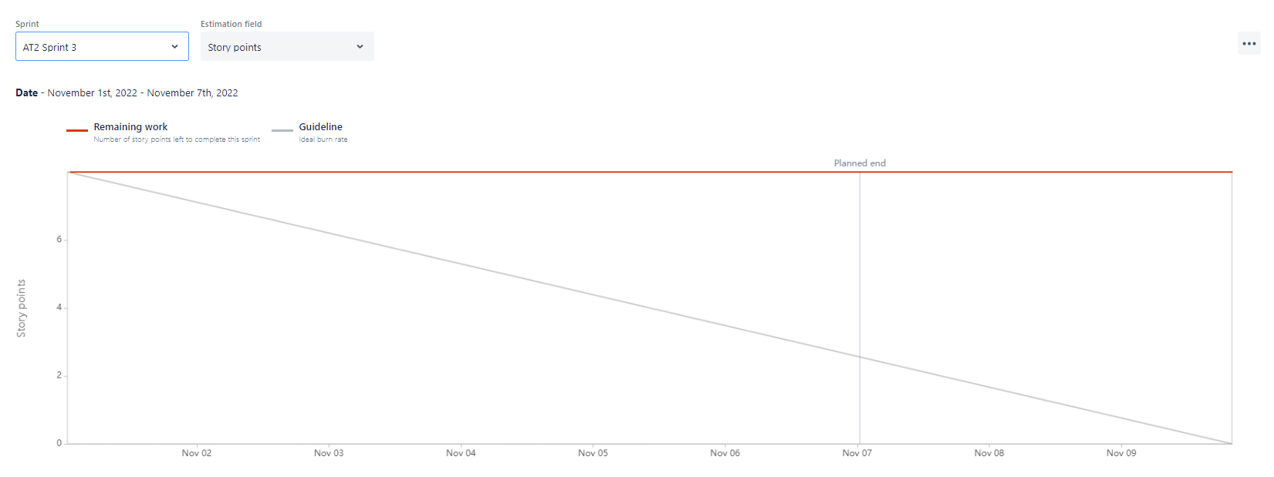

**Sprint Report :-**

